**Practical Related Questions**

1. **List all the methods related to camera class.**

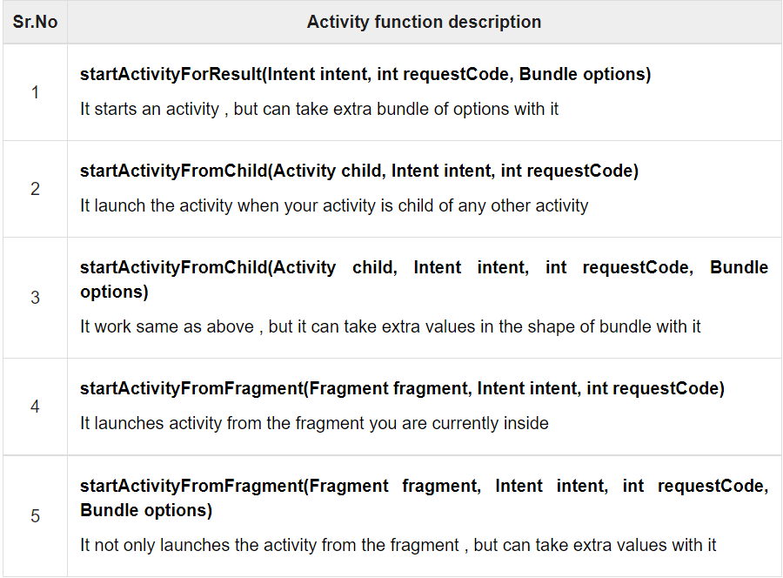

**Exercise**

**MainActivity.java**

package com.example.cameracentricapp;  
  
import androidx.appcompat.app.AppCompatActivity;  
  
import android.content.Intent;  
import android.graphics.Bitmap;  
import android.net.Uri;  
import android.os.Build;  
import android.os.Bundle;  
import android.os.Environment;  
import android.provider.MediaStore;  
import android.view.View;  
import android.widget.Button;  
import android.widget.ImageView;  
import android.widget.MediaController;  
import android.widget.Toast;  
import android.widget.VideoView;  
  
import java.io.File;  
  
public class MainActivity extends AppCompatActivity {  
  
 private ImageView imgvw;  
 private Button captureBtn, videoBtn;  
 private VideoView videovw;  
 private static final int *Image_Capture_Code* = 1;  
 private static final int *VIDEO_CAPTURE* = 101;  
 Uri videoUri;  
  
 @Override  
 protected void onCreate(Bundle savedInstanceState) {  
 super.onCreate(savedInstanceState);  
 setContentView(R.layout.*activity_main*);  
  
 imgvw = (ImageView) findViewById(R.id.*imageView*);  
 captureBtn = (Button) findViewById(R.id.*button*);  
 videoBtn = (Button) findViewById(R.id.*button2*);  
 videovw = (VideoView) findViewById(R.id.*videoView*);  
  
 MediaController mediaController= new MediaController(this);  
 mediaController.setAnchorView(videovw);  
 videovw.setMediaController(mediaController);  
  
  
 captureBtn.setOnClickListener(new View.OnClickListener(){  
 @Override  
 public void onClick(View view){  
 Intent cam = new Intent(MediaStore.*ACTION_IMAGE_CAPTURE*);  
 startActivityForResult(cam, *Image_Capture_Code*);  
 }  
 });  
 videoBtn.setOnClickListener(new View.OnClickListener(){  
 @Override  
 public void onClick(View view){  
 File mediaFile =  
 new File(Environment.*getExternalStorageDirectory*()  
 + "/myvideo.mp4");  
 if (Build.VERSION.*SDK_INT* < 24) {  
 videoUri = Uri.*fromFile*(mediaFile);  
 } else {  
 videoUri = Uri.*parse*(mediaFile.getPath()); // My work-around for new SDKs, worked for me in Android 10 using Solid Explorer Text Editor as the external editor.  
 }  
  
 Intent cam = new Intent(MediaStore.*ACTION_VIDEO_CAPTURE*);  
  
 cam.putExtra(MediaStore.*EXTRA_OUTPUT*, videoUri);  
 startActivityForResult(cam, *VIDEO_CAPTURE*);  
 }  
 });  
 }  
 @Override  
 protected void onActivityResult(int requestCode, int resultCode, Intent data){  
 super.onActivityResult(requestCode, resultCode, data);  
  
 if(requestCode == *Image_Capture_Code*){  
 if(resultCode == *RESULT_OK*){  
 videovw.setVisibility(View.*INVISIBLE*);  
 Bitmap bp = (Bitmap) data.getExtras().get("data");  
 imgvw.setVisibility(View.*VISIBLE*);  
 imgvw.setImageBitmap(bp);  
 }  
 else if(resultCode == *RESULT_CANCELED*){  
 imgvw.setVisibility(View.*INVISIBLE*);  
 videovw.setVisibility(View.*INVISIBLE*);  
 Toast.*makeText*(this, "Cancelled", Toast.*LENGTH_LONG*).show();  
 }  
 }  
 else if(requestCode == *VIDEO_CAPTURE*){  
 if(resultCode == *RESULT_OK*){  
 videovw.setVisibility(View.*VISIBLE*);  
 imgvw.setVisibility(View.*INVISIBLE*);  
 videovw.setVideoURI(videoUri);  
  
 videovw.start();  
 }  
 else if(resultCode == *RESULT_CANCELED*){  
 imgvw.setVisibility(View.*INVISIBLE*);  
 videovw.setVisibility(View.*INVISIBLE*);  
 Toast.*makeText*(this, "Cancelled", Toast.*LENGTH_LONG*).show();  
 }  
 }  
 }  
}

**activity_main.xml**

<?xml version="1.0" encoding="utf-8"?>  
<androidx.constraintlayout.widget.ConstraintLayout xmlns:android="http://schemas.android.com/apk/res/android"  
 xmlns:app="http://schemas.android.com/apk/res-auto"  
 xmlns:tools="http://schemas.android.com/tools"  
 android:layout_width="match_parent"  
 android:layout_height="match_parent"  
 tools:context=".MainActivity">  
  
 <Button  
 android:id="@+id/button"  
 android:layout_width="171dp"  
 android:layout_height="65dp"  
 android:text="Take Picture"  
 app:layout_constraintBottom_toTopOf="@+id/button2"  
 app:layout_constraintEnd_toEndOf="parent"  
 app:layout_constraintStart_toStartOf="parent"  
 app:layout_constraintTop_toBottomOf="@+id/imageView" />  
  
 <ImageView  
 android:id="@+id/imageView"  
 android:layout_width="275dp"  
 android:layout_height="280dp"  
 android:visibility="invisible"  
 app:layout_constraintEnd_toEndOf="parent"  
 app:layout_constraintStart_toStartOf="parent"  
 tools:layout_editor_absoluteY="140dp"  
 tools:srcCompat="@tools:sample/avatars" />  
  
 <Button  
 android:id="@+id/button2"  
 android:layout_width="169dp"  
 android:layout_height="55dp"  
 android:layout_marginBottom="32dp"  
 android:text="Capture Video"  
 app:layout_constraintBottom_toBottomOf="parent"  
 app:layout_constraintEnd_toEndOf="parent"  
 app:layout_constraintHorizontal_bias="0.504"  
 app:layout_constraintStart_toStartOf="parent" />  
  
 <VideoView  
 android:id="@+id/videoView"  
 android:layout_width="295dp"  
 android:layout_height="298dp"  
 android:visibility="invisible"  
 app:layout_constraintBottom_toTopOf="@+id/button"  
 app:layout_constraintEnd_toEndOf="parent"  
 app:layout_constraintStart_toStartOf="parent"  
 app:layout_constraintTop_toTopOf="parent"  
 app:layout_constraintVertical_bias="0.653" />  
</androidx.constraintlayout.widget.ConstraintLayout>